Introduction
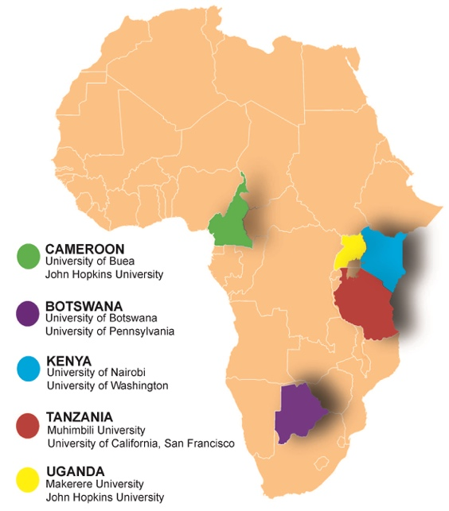
In 2009, a consortium was formed with 8 African and U.S. universities to create a model program to provide future global health leaders with practical skills that are currently not part of traditional training in the health professions. The goal was to strengthen health systems in Kenya, Tanzania, Uganda and Botswana. The group adopted the name Afya Bora Consortium (Swahili for “Better Health”) to reflect the goal of an Africa-centered fellowship that would bring together institutions from the South to train health professionals from the Ministry of Health, PEPFAR implementing partners and universities in impactful leadership, high-quality program management and rigorous evaluation.
Afya Bora Consortium Member Institutions by Country

Program Structure
The 1-year fellowship includes eight 1-week core interactive, didactic modules divided into three blocks that are flanked by two 4.5-month mentored, project-oriented rotations at Ministries of Health, PEPFAR implementing partners, and other non-governmental organizations (NGOs). Projects are programmatic, policy-oriented, or research-based:
- 70% of projects target HIV testing, prevention and treatment
- 1/3 of projects focus on women, adolescent, and girls’ health.

Distinguishing Features
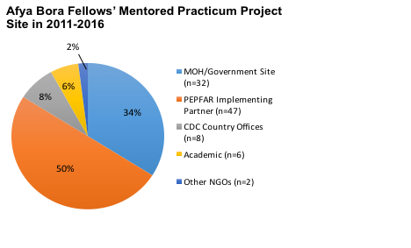
- Africa-centric focus emphasizing HIV/AIDS: The majority of trainees (84%, n=100) and majority of training sites, faculty and mentors are African. The use of training in leadership and management relevant to HIV/AIDS provides skills that can be used to address the current AIDS pandemic in Africa.
- Emphasis on skills and experience to lead large, evidence-based programs: The model fills a critical health leadership gap that currently exists in many African nations. It delivers leadership training and relevant skills to a select group of Africans early in their career, creating a cadre of individuals essential to country ownership of large-scale programs. It also prepares Fellows to design, implement, scale-up, evaluate and iteratively improve programs that link preventive and curative health services, policy and training.
- Interdisciplinary framework across medicine, nursing and other health-related disciplines: We believe that training across disciplines is critical to the development of effective health leadership in Africa and around the globe. In most African countries, nurses are making important healthcare decisions but not well-represented in leadership positions. Afya Bora Fellows from Nursing, Medicine, and other health disciplines learn and work together and nurses emerge alongside doctors with an increased capacity to lead and be recognized for their leadership abilities.
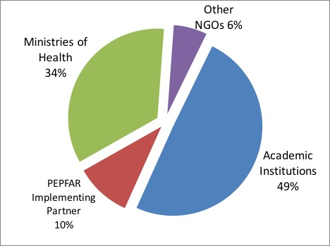
- Create important linkages between Ministries of Health, NGOs, and Academic Institutions: This fellowship works to build bridges between Ministries of Health, NGOs, and academic institutions by empowering partnering universities to offer leadership training directly relevant to the needs of MOH and PEPFAR implementing partners. Afya Bora Fellows come from diverse backgrounds and complete a mentored practicum project at different sites, exposing them to another public-health organization.
Institution at time of recruitment for Afya Bora Fellows in 2011-2015

- Flexible platform for scale-up: The Afya Bora model can be scaled up in a number of ways, such as expanding the program by including other interested countries in Africa or replicating the program by initiating similar consortia, perhaps in other geographic areas. Within the last 5 years of the program, we have been able to scale-up to two additional countries. In 2015, we started training fellows in Cameroon, and University of Buea joined the Consortium. This year the Chinese Medical Board is funding their faculty to participate in the Fellowship and complete a project in Kenya or Uganda.

Now in its sixth year, the Afya Bora Consortium Fellowship has enrolled 43 nurses, 54 doctors, and 3 public health professionals from Botswana, Cameroon, Kenya, Tanzania, Uganda and the United States. Of the 80 program graduates, 100% of African fellows have remained in their home countries during the last 5 years. Emphasis on an interdisciplinary approach has helped us achieve gender equity within our trainee cohort with 64% female Fellows. Recently, in April 2016 we selected our fifth cohort of 20 Fellows to start in June 2016.

